**Create Instance**

1. Create a module which takes the following input values:

* vpc id
* list of open ports



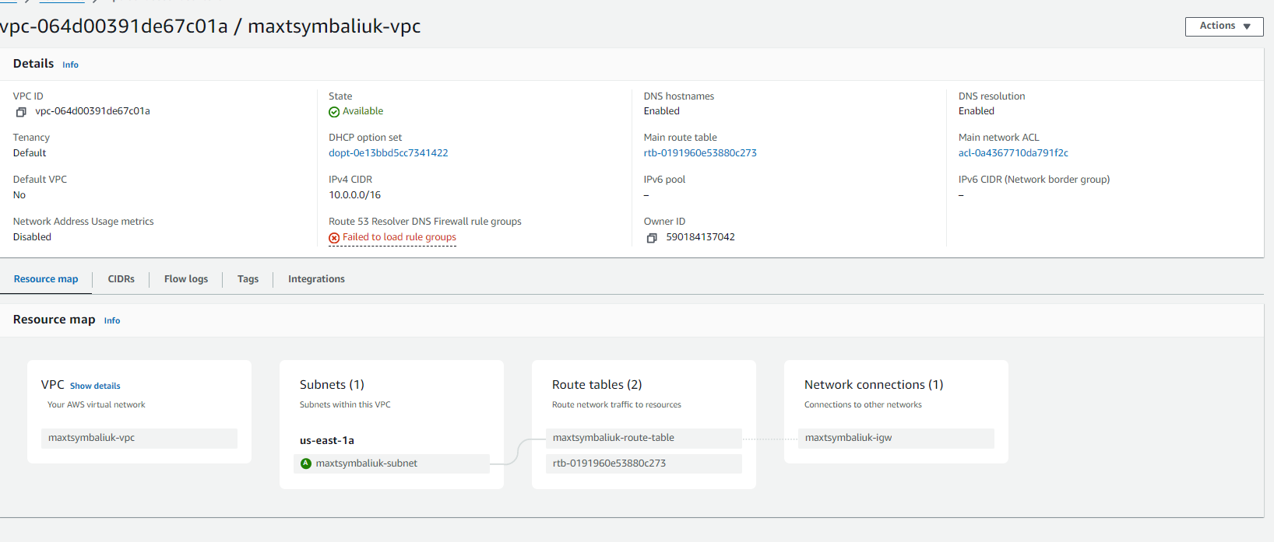

1. Then creates in eu-north-1 region:

* security group which allows access from anywhere to ports from input in specified VPC
* public EC2 instance in specified VPC with installed default nginx server or nginx running in container

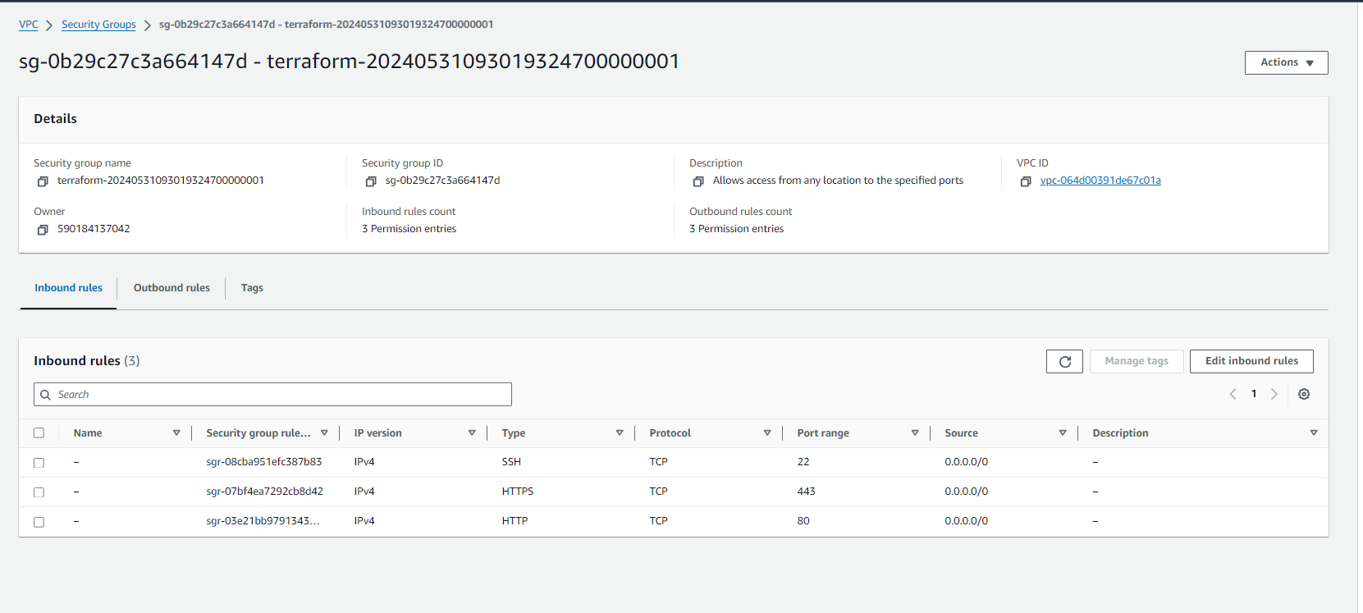

1. Then outputs:

* IP of created instance

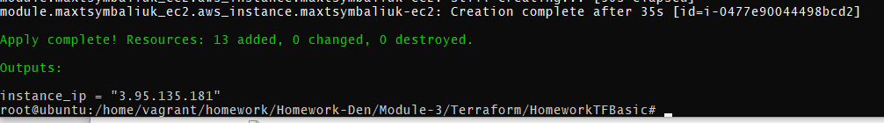

1. Use http://IP to confirm that nginx is running

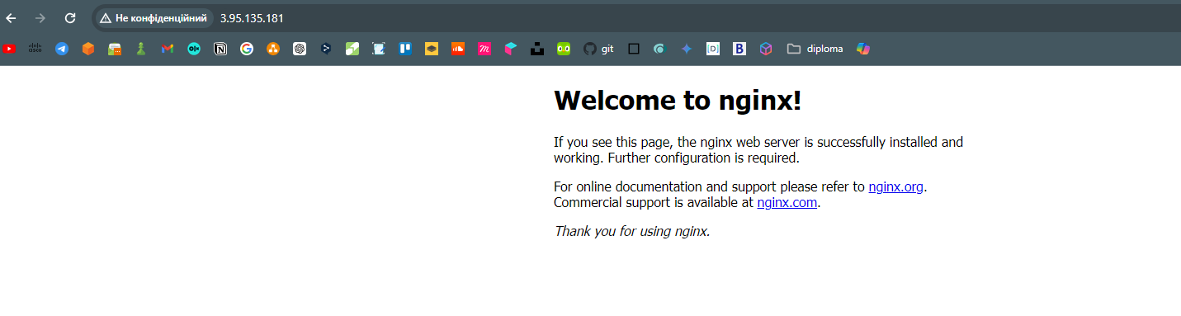

**Backend**

1. Configure S3 backend for your project
2. Use the terraform-state-danit-devops-2 bucket in eu-central-1 region
3. Configure unique path for your state by using your login name
4. Make sure that file is created in the bucket and gets updated when you change infrastructure

